Cambridgeshire and Peterborough
Multi-agency Protocol
for
Working with people who display
hoarding behaviour

Final Version, created 15 March 2016

Written by Wendy Coleman (CFRS) and Deborah Latham (CHS Group)















Section | Contents | Page Number
1 | Introduction | 4
2 | Organisations the Protocol Applies To | 5
3 | Aims of the Protocol | 5
4 | Definition of Hoarding | 6
5 | General Characteristics of Hoarding | 6
6 | Hoarding and Mental Health | 7
7 | Safeguarding and Hoarding | 8
8 | Mental Capacity and Hoarding | 9
9 | Information Sharing | 10
10 | Multi-agency meetings and action planning | 11
11 | The Approach to Take | 13
12 | Clearances | 14
13 | Environmental Health Powers | 15
14 | Fire Service | 17
15 | Police | 17
Appendix
1 | Guidance on Hoarding Insight Characteristics | 19
2 | Hoarding Myths and Truths | 20
3 | Relevant Agencies and Responses | 22
4 | Additional Contacts | 24
5 | Clutter Image Rating (CIR) Tool | 25
6 | CIR Images - Bedroom | 26
7 | CIR Images – Living Room | 27
8 | CIR Images - Kitchen | 28
9 | Mind Cambridgeshire Support to Recover S2R  - Criteria  - Referral form | 29 30
10 | Handy tips for People who hoard booklet | 31
11 | Risk Assessment:  - Risk Scoring Tool  - Generic Risk Assessment Form  - Guidance Questions  - Premises Risk Assessment Checklist | 38  39  41  43  45
12 | Top Tips - For practioners of high risks from fire | 49

1.0 Introduction

1.1 This protocol offers clear guidance to staff working with people who exhibit hoarding behaviors. It sets out a framework for multi-agency partners to work together, using an outcome focused, solution based model. This protocol has been developed in partnership with a range of statutory and non-statutory partners across Cambridgeshire and Peterborough.

1.2 The Care Act 2014 recognises hoarding as one of the manifestations of self-neglect and requires all public bodies to safeguard people at risk. To deal with the risks effectively requires a collaborative and integrated approach between agencies.

1.3 The protocol recognizes that responding to a situation which involves a person compulsively hoarding is highly complex, as it involves risk to life, is subject to more than one area of legislation and involves the health and wellbeing of the person at risk and any others in the household. It therefore requires a multi-agency approach.

1.4 This protocol aims therefore to ensure this collaborative approach through coordinated multi agency partnership working with people who exhibit hoarding behaviors, in a way that is meaningful to the person who has hoarding behaviors and their families and in a way that reduces duplication of effort for the agencies involved. The protocol aims to facilitate positive and sustainable outcomes for people who demonstrate hoarding behavior, by involving them in the process of managing their behavior at all stages.

1.5 It is recognised that people who display hoarding are at high risk of injury or death as a result of a fire. Cambridgeshire Fire and Rescue Service (CFRS) emergency call data analysis shows that this is the case, with fire fatalities across the County during and a growing number of serious injuries in recent years. National research supports these findings (Fire Statistics Monitoring by the Department of Community and Local Government).

1.6 The risk of a fire starting is increased due to combustible materials being stored close to, or in contact with heat sources such as light fittings, smoking materials cookers and heaters, and when electrical appliances are permanently plugged in and switched on under several layers of clutter.

1.7 This risk is increased further when the clutter reaches extreme levels and when utilities such as electricity and gas are disconnected and lead to unsafe practices such as using camping stoves and candles. Entry and exits can be restricted, and present additional risk to neighbours by the increased likelihood of fire moving to adjoining properties. The structural integrity of the building may be compromised during and after fire fighting operations, due to the absorption of water by the hoarded materials.

1.8 CFRS, Cambridgeshire County Council, Peterborough City Council, Cambridgeshire and Peterborough NHS Foundation Trust, Registered Social Landlords and other community focussed organisations wish to work together to reduce the significant risks associated with hoarding and to promote health, safety and wellbeing.

1.9 Self-neglect, which includes hoarding, is currently covered in training through the ‘Making Safeguarding Personal’ course run by Cambridgeshire County Council (see the County Council Safeguarding training website).

2.0 Organisations the Protocol Applies To

2.1 This protocol applies to all staff working in organisations which have signed up to the protocol in Cambridgeshire. This includes Peterborough.

2.2 Note that the protocol stands as good practice guidance for any organisation that has identified a hoarding issue, including during the course of providing housing management, support and domiciliary care and for any other agency delivering services in the course of which their staff may come across a person with hoarding.

The agencies signed up to the protocol include and are not limited to:

Cambridgeshire Fire and Rescue Service
Cambridgeshire County Council
Cambridgeshire and Peterborough NHS Foundation Trust
Cambridgeshire Home Improvement Agency
Cambridge City Council
Circle Housing
CHS Group
Care Network Cambridgeshire
East of England Ambulance Service
Fenland District Council
Mind in Cambridgeshire
Recovery College East
South Cambridgeshire District Council
Peterborough City Council

By signing the protocol each agency is committing to engaging fully in partnership working to achieve the best outcome for the person who displays hoarding , while meeting their own requirements and professional duties.

- Aims of the Protocol

3.1 The aims of this protocol are to:

Provide guidance on investigating, sharing and understanding information about the risk and challenges related to hoarding, from different professional and community perspectives; and to improve inter-agency knowledge of the legislation that relates to hoarding and to work with incidents in an evidence based, structured, systematic, co-ordinated and consistent way across the professions involved.
    - Establish best practice in working with people who display hoarding , so that staff know how to provide a personalised response in each case which is most likely to gain the best outcome for the person whilst reducing risk, and that respects the person’s rights, choices and autonomy.

    - Develop multi-agency solutions, maximising the use of existing services and resources of professional support and monitoring (e.g. Housing Officers, care and support workers, property maintenance) and focussing on prevention and modification of hoarding s, aiming to reduce the need for formal or compulsory solutions.

4.0 Definition of Hoarding

‘Hoarding’ is the excessive collection and retention of any material to the point that it impedes day to day functioning (Frost & Gross, 1993). Pathological or compulsive hoarding is a specific type of characterised by:

- Severe “cluttering” of the person’s home so that it is no longer able to function as a viable living space.

- Acquiring and failing to throw out a large number of items that would appear to hold little or no value and would be considered rubbish by other people.

- Significant personal distress or impairment of work or social life (Kelly O (2010) What is hoarding? Journal of Hoarding)

5.0 General Characteristics of Hoarding

One or more of the following may be observed:

- Fear and anxiety: compulsive hoarding may have started as a learned behaviour following a significant event such as bereavement. The person hoarding believes that buying or saving things will relieve the anxiety and fear they feel. The hoarding effectively becomes their comfort blanket. Any attempt to discard hoarded items can induce feelings varying from mild anxiety to full panic attack with sweats and palpitations.

- Long term pattern: possibly developed over many years, or decades, of ‘buy and drop’, collecting and saving, with an inability to throw away items without experiencing fear and anxiety.

- Excessive attachment to possessions: People who hoard may hold an emotional attachment to items that most people would feel is inappropriate.

- Indecisiveness: people who hoard struggle with making a decision to discard items that are not necessary to keep, including rubbish. E.g. tins, newspapers, magazines, bottles.
- Unrelenting standards: people who hoard will often find fault with others, or require others to perform to excellent standards while struggling to organise themselves and to complete daily living tasks.

- Socially isolated: people who hoard will typically alienate family and friends and may be embarrassed to have visitors. They may refuse home visits from professionals.

- Large number of pets: some people who hoard may keep a large number of animals. These may become a source of complaints by neighbours. They may ‘rescue strays’.

- Mentally competent: people who hoard are typically able to make reasonable decisions that are not related to the hoarding.

- Extreme clutter: hoarding may prevent the person from using several or all the rooms of their property for their intended purpose.

- Churning: people with hoarding may move items from one part of their property to another, without actually discarding anything.

- Self-Care: a person who hoards may appear unkempt and dishevelled, due to lack of toileting or washing facilities in their home. Some people who hoard will use public facilities in order to maintain their personal hygiene and appearance.

- Poor insight: a person who hoards will typically see nothing wrong with their and the impact it has on themselves and others.(see Appendix 1)

5.2 The Chief Fire Officers Association produced a document to dispel myths about hoarding (see Appendix 2).

6.0 Hoarding and Mental Health

6.1 Hoarding can be a symptom of an underlying mental disorder. Hoarding is classified under the International Classification of Disorders system as a mental or al disorder (ICD 10). Hoarding Disorder is distinct from the act of ‘collecting’ or keeping your home in a generally cluttered or messy state.

6.2 The main difference between a person who has hoarding and a collector is that people who have hoarding have strong emotional attachments to their items, and these attachments are well in excess of the real value of the items. Anything may be hoarded by the person at their home – inside or outside the property. Hoarding has no relation to gender, age, ethnicity, socio-economic status, educational or occupational history, or tenure type.

Commonly hoarded items include things like:

- Inanimate objects – these are the most commonly hoarded items and may be one type of object, or a collection of a mixture of objects such as old clothes, newspapers, magazines, books food, containers, bills, receipts or letters, clothes, toys, videos, DVD, CDs, or even medical equipment.

- Animal Hoarding – this is the obsessive collecting of animals, often with an inability to provide minimal standards of care. The hoarder may be unable to recognise that the animals could be at risk, because they feel they are rescuing them. Often animal hoarders may feel like they are the only ones capable of caring for the animals, so may not be willing to find alternative accommodation for them, yet at the same time be unable to care for them. The environmental health conditions that having so many animals may create can be so bad that they may be considered to amount to animal cruelty and be punishable by law. The homes of people who hoard animals may be characterised by an accumulation of animal faeces and infestation by insects.

- Data Hoarding – this is a recent phenomenon, about which there is little research. People that hoard data may present with same issues that are symptomatic of hoarding, for example excessive data storage equipment – computers and other electronic storage devices, and paper.

7.0 Safeguarding and Hoarding

7.1 The Care Act 2014 (Statutory Guidance, Chapter 14) recognizes ‘self-neglect’ as a category of abuse and requires public agencies to act to mitigate the risks. The Care Act describes self-neglect as a wide range of behaviors, i.e. neglecting to care for one’s personal hygiene, health or surroundings and includes behavior such as hoarding. (Chapter 14 of the Care Act 2014 replaces the previous guidance contained in ‘No Secrets’.)

7.2 Self-neglect may affect people in different ways and at various times in their lives. It is important to recognize that in the majority of cases, self-neglect is best addressed through care/support/treatment delivered by health and social care services. This might include interventions as appropriate under the Mental Capacity Act 2005 or the Mental Health Act 1983. Non health and social care professionals identifying a person with hoarding behavior should seek the advice of health/social care services.

Where the adult may not engage with any services, or where there may be
challenges in delivering care and support, self-neglect may persist and in some circumstances the risks to the individual may increase and could have a significant impact on the person’s wellbeing.
Where the issue of self-neglect is already quite extreme, i.e. when it is recognized as presenting a significant risk to the health or wellbeing of the adult or any members of the family living with them, including children, and when the usual care, support and treatment options have been unsuccessful in reducing the risks, the issue should be referred to the Cambridgeshire County Council safeguarding team for advice.

8.0 Mental Capacity and Hoarding

8.1 When a person’s hoarding behavior poses a serious risk to their health and safety, professional intervention will be required. With the exception of statutory legal requirements, any intervention or action proposed must be with the person’s consent.

8.2 The Mental Capacity Act 2005 provides a statutory framework for people who may lack capacity to make their own decisions.

The Act has five statutory principles to serve the person’s ‘best interests’, which underpin the legal requirements:

- A person must be assumed to have capacity unless it is established that they lack capacity.

- A person is not to be treated as unable to make a decision unless all practical steps to enable them to make a decision have been taken without success.

- A person is not to be treated as unable to make a decision merely because he/she makes an unwise decision.

- An act done or decision made, under this act for or on behalf of a person who lacks capacity, must be done or made in his or her best interests.

- Before the act is done, or the decision is made, regard must be had to whether the purpose for which it is needed can be as effectively achieved in a way that is less restrictive of the person’s rights and freedom of action.

8.4 In cases of extreme hoarding behavior, the very nature of the person’s environment must mean that professionals question whether the person has capacity to consent to their proposed action/intervention, and this should therefore trigger a capacity assessment. This is supported by the MCA code of practice, which states that one of the reasons why people may question a person’s capacity to make a specific decision is “the person’s behavior or circumstances cause doubt as to whether they have capacity to make a decision” (4.35 MCA Code of Practice, p.52).

8.5 Any mental capacity assessment carried out in relation to hoarding behavior must be time specific, and relate to a specific intervention/action, in line with the Act. The professional responsible for undertaking the capacity assessment will be the person who is proposing the specific intervention/action, and this person is referred to as the ‘decision-maker’. Although capacity assessments sometimes require input from other people and professionals, it is the responsibility of the decision maker to coordinate and ‘own’ the capacity assessment overall.

8.6 Where the person is subject to multi-disciplinary care, the professional with greatest responsibility for the specific decision is likely to be the decision maker and should ideally assess capacity. Where this is in doubt agreement should be sought within the multidisciplinary team. If it is evidenced that a specialist capacity assessment (such as by a psychologist) is needed, and which is being relied on for this decision, the decision-maker must be satisfied that this assessment is fit for purpose. Due to the complexity of such cases, there must be a ‘best interests meeting’ with relevant professionals to oversee the process. The decision-maker is responsible for making the final decision about the person’s capacity.

8.7 If after assessing mental capacity it is found that the person does lack capacity to consent to the specific action/intervention, then the decision-maker must be able to demonstrate that they have met the requirements of the ‘best-interests checklist’ and that a formal mental capacity assessment has been undertaken which demonstrates that the person lacks capacity to make an informed decision.

8.8 The mental capacity assessment would be in addition to the generic risk assessment, and would follow Cambridgeshire County Council guidance. (The generic risk assessment form is provided in Appendix 10 below.)

8.9 In particularly challenging and complex cases, it may be necessary to refer to the Court of Protection to make the ‘best interests’ decision. The new Court of Protection was set up under the Mental Capacity Act 2005. It can make decisions on whether people have capacity in relation to particular decisions, make decisions on their behalf, appoint or remove people who make decisions on people’s behalf.

9.0 Information Sharing

9.1 For agencies to work collaboratively and effectively to reduce the risks of hoarding behavior, information will need to be shared.

9.2 Sharing information must be in line with the Data Protection Act 1998, under which we all have the responsibility to ensure that personal information is processed lawfully and fairly. All people have a right to view any information held about them. Practitioners should consider this when they are recording information about a person.

9.3 There are various formal information sharing agreements in Cambridgeshire under the Cambridgeshire Information Sharing Framework, which includes the following though not limited to: Safer Peterborough Partnership, Cambridgeshire and Peterborough Safeguarding Adults Boards, Multi-Agency Safeguarding Hub (MASH).

9.4 Each agency will ensure that when it shares information about hoarding, this is done on a ‘need to know’ basis and that all information is transferred in a secure format. This means for example that CFRS will share information with the housing provider and vice versa. If the housing is provided by a private landlord efforts will be made to share the information with the landlord in the interest of mitigating risk. If it is a more significant case of hoarding, information may also be shared with Cambridgeshire County Council Safeguarding Board.

9.5 For the purposes of this protocol we have adopted the following principle:

9.5.1 Adults have a right to independence, choice and self-determination. This right extends to them being able to have control over information about themselves and to determine what information is shared. Therefore the person’s written consent should be obtained before sharing information and it should routinely be explained what information may be shared with other people or organizations. The person’s wishes should always be considered.

9.6 People ‘at risk’ within the terms of the Care Act 2014

9.6.1 Acting to protect a person who under the Care Act 2014 would be deemed to be an adult at risk is based on the general principle that any incident of suspected or actual abuse may need to be shared with relevant others. Where members of the person’s family, children or older relatives, or neighbors, are at risk, the matter is dealt with in the best interests of those people and if necessary information is shared without the consent of the person with the hoarding behavior.

9.6.2 In the case of an adult at risk within the terms of the Care Act 2014, it is important to remember that information given to an individual member of staff belongs to the organization and not to that individual member of staff. An individual member of staff cannot give personal assurance of confidentiality to a person at risk.

9.6.3 Any need to protect the interests of an organization must not override the need to protect the person(s) at risk.

9.6.4 Whilst working within the principles of maintaining confidentiality is very important, it must not lead to a failure to take action to protect of a person at risk of self-neglect, abuse or harm.

Decisions about which information is shared and with whom, need to be taken on a case by-case basis. Regardless of whether information is shared with or without the consent of the person at risk, the information shared should be:

- Necessary for the purpose for which it is being shared, i.e. shared only with those who have a need for it
- Justifiable and proportionate
- Accurate and up to date
- Shared in a timely fashion
- Shared accurately
- Shared securely

9.6.6 When data is shared, the receiving organization will retain the data, within data protection requirements, only for as long as is relevant for their input, and then it is destroyed. It is expected that the lead team in the case would keep the details of the case for as long as necessary and within data protection requirements.

10.0 Multi-agency meetings and action planning

10.1 Hoarding behavior is a complex condition which significantly impacts on the person’s daily life and the circumstances in which they live. This protocol recognizes that a multi-agency approach is often best for the person, the property and the community because it will deliver the most comprehensive, consistent and personalized action to resolve or modify the hoarding issue and will avoid duplication of agency effort and potentially wasted resources.

10.2 Multi-agency meetings will identify the lead agency, be documented and agree an action plan which contains goals and timescales. All parties involved will agree their role. The action plan needs to be informed by the person with the hoarding behavior, taking into account their views about how changes can realistically be achieved and risks reduced. Ideally the person will be present at the meeting. The plan will take account of the time needed to build trust to maximize the likelihood of success. The action plan should be signed by the individual to indicate their agreement to it and their willingness to accept support and engage with the relevant agencies. The idea is to work in a sensitive way with the person to enable them to engage in agreeing a realistic plan. If the person will not engage then the professionals concerned will need to agree a plan which will continue to try to engage the person and which in cases of significant health and safety risk could include enforcement of actions without the person’s agreement, but this is a last resort. (See sections 13, 14 and 15. The plan will include a realistic pace of change/reduction in the amount of hoarded items. The priority must always be mindful of health and safety in relation to the wellbeing of the person and their neighbours, so these risks must be dealt with as a matter of priority. A longer timescale is acceptable for lesser risks.

10.3 Priority risks are for example: combustible items piled up near the central heating boiler, items blocking exit routes, routes to the toilet and washing facilities and essential appliances such as the cooker, items covering electrical sockets and switches.

10.4 The lead agency is responsible for checking progress with the person against the plan and, as necessary, arranging reviews with the multi-agency group and ideally with the person present, where further actions can be agreed to make progress.

10.5 Note that the forms of intervention may differ between tenanted and individual owned properties. Social landlords have employees that are responsible for housing management, including working with residents with anti-social behavior. Social care and support organizations may be involved delivering support or personal care to people who are renting their home or own it, and at least their involvement in monitoring the hoarding issue should be sought, if they cannot do more to encourage the person to modify their behavior. Likewise, friends, relatives and supportive neighbors may be helpful in negotiating changes in behavior, supporting the person to make the changes and monitoring the situation and raising issues.

The types of Personal Protective Equipment (PPE) recommended should also be noted in the action plan. Relevant PPE should be worn as required to suit the conditions when supporting an individual to clear items from their home. The types of PPE commonly used are:
- Protective suit
- Disposable gloves
- Safety boots (with soles that provide protection against injury from sharp objects)
- Air filter mask
- Eye protection
- Respirator
- Alcohol hand gel

11.0 The approach to take

11.1 Bearing in mind the complexity of hoarding behavior, especially the fact that it tends to be rooted in anxiety disorders, it is important that the approach taken to tackle the issues that the behavior raises is humane.

11.2 The person with hoarding behavior may well not respond favorably to a simple clearance of their property. Such action is likely to be extremely upsetting for them and will almost certainly exacerbate any mental ill health and add to their stress.

11.3 Clearing items is unlikely to be a solution in the longer term. The way forward is by providing sensitive support and working with the person to make positive changes. Other agencies may also need to be involved (see section 10 about multi-agency meetings and action planning).

11.4 Every hoarding situation will be different, although there may be similarities. Staff need to consider the particular circumstances and individual views of the person with hoarding behavior, to develop a personalized and supportive approach to resolving the situation. Such an approach is most likely to achieve a positive outcome.

11.4.1 Hoarding can be a complex disorder and is frequently combined with Anxiety or Depression. This can often require long term intervention to deal with the persons Mental Health issue to ensure that the Hoarding Disorder is dealt with effectively. Mind of Cambridgeshire offer different services to provide Support for any Mental Health issues. (See Appendix 3 for contact details)

11.5 The member of staff identifying the hoarding concern needs to visit the person and do the following:

11.5.1 Assess the level of clutter – using the Clutter Image Rating (CIR) tool
(See Appendix 5, 6, 7, 8)

11.5.2 Assess the risks using the Guidance Questions, Premises Risk Assessment Checklist; Risk Assessment form and Scoring Tool (see Appendix 10)

11.5.3 Assess the Hoarding Insight Characteristics of the person with hoarding (see Appendix 1)

11.6 Depending on the results of these assessments then do the following:

For CIR score 1-3:
- Provide advice to the person about risks and safety, ask for fire safety advice from Cambridgeshire Fire and Rescue Service
- Encourage the person to self-refer to agencies for assistance
(See Appendix 3)
- Ideally complete an action plan based on the results of the CIR, risk and hoarding insight characteristics assessments.

For CIR score 4-9:
- Instigate a multi-agency meeting with the relevant agencies present. The main agencies and the types of action they may take are listed in Appendix 4 Relevant Agencies and Responses.
- Complete an action plan based on the results of the CIR, risk and hoarding insight characteristics assessments. The action plan, and when it will be reviewed, will be agreed at the multi-agency meeting and a next meeting date will be arranged.

12.0 Clearances

12.1 Enforced clearance of items against the will of the person with the hoarding behavior will only be undertaken when these four points are satisfied:
(a) other approaches have been exhausted
(b) the risks caused by the hoarding warrant clearance
(c) the agreement of the multi-agency group has been obtained
(d) it is proportionate to the scale of the issue.

12.2 By ‘proportionate’ we mean the areas of highest fire risk may be the only areas that need to be cleared, and not the whole house. For the rest of the property it may be just enough to clear sufficient areas to enable the person to access all of the rooms and their facilities.

12.3 The action plan should note the relevant agency that will work with the person with hoarding and provide support during any clearance process, at the same time encouraging the person to tackle some of it on their own. It is important to encourage the person to engage with actions to clear the property in a way that they can ‘own’, working if possible with family, friends and voluntary agencies. Finding out what will motivate the person to participate in the clearance is important – for example Cambridgeshire Housing Improvement Agency completing home improvements subject to clearance of clutter.

There are a few simple tips that will support the person and that can be adapted to suit their needs and preferences, for example:

- Start the clearance in one important area first, for example around the cooker, or heating source.

- Apply the ‘fifteen minute rule’ – set the timer for 15 minutes to clear clutter. Once this has been completed encourage the individual to do something they like to do and then return to undertake another fifteen minutes later the same day.

- Wall chart – complete a wall chart to note every bag of clutter that leaves the property, e.g. 10 bin liners of clothes to the charity shop, 2 bags of medicines to the doctor’s surgery, 1 bag of books to a charity shop.

12.5 Clearances that require a third party to come in to facilitate the work are likely to need to be paid for by the person with hoarding. The person can source and employ a contractor themselves, or the district council may arrange for a company to do the job and recharge the person. If enforcement action is needed to carry out a clearance, it will be recharged to the person.

12.6 Enforced clearance is a last resort and is often not a longer term solution. (because it is highly likely that hoarding behavior will continue regardless),

Therefore following a clearance the multi-agency group must identify how ongoing/regular support will be provided in an endeavour to prevent the
re-accumulation of hoarded items.

13.0 Environmental Health Powers

This section outlines legal routes that might be taken to resolve a hoarding issue. The agencies using this Hoarding Protocol see legal enforcement action as a last resort, only to be utilized when all other efforts are exhausted.

Public Health Act 1936, Section 79: Power to require removal of noxious matter by occupier of premises

The Local Authority (LA) will always try and work with a householder to identify a way to reduce or eliminate hoarding, however in cases where the resident is not willing to co-operate the LA can serve notice on the owner or occupier to “remove accumulations of noxious matter”. Noxious not defined, but usually is “harmful, unwholesome”. No appeal is available. If not complied with within 24 hours, the LA can do works in default and recover expenses.

Public Health Act 1936, Section 83: Cleansing of filthy or verminous premises

Where any premises, tent, van, shed, ship or boat is either:

a) filthy or unwholesome so as to be prejudicial to health; or
b) verminous (relating to rats, mice other pests including insects, their eggs and larvae)

Filth is a euphemism for excrement, animal or human. Due to case law the definition of “prejudicial to health” is limited and means “likely to cause a threat of disease”. It does not include the likelihood of personal injury. Nuisance has its common law meaning of something which materially interferes with the use of another’s land.

The LA serves notice requiring: clearance of materials and objects that are filthy, cleansing of surfaces, carpets etc. within 24 hours or more. If not complied with, Environmental Health (EH) can carry out works in default and charge. No appeal is available against the notice, but an appeal can be made against the cost and reasonableness of the works on the notice.

Public Health Act 1936, Section 84: Cleansing or destruction of filthy or verminous articles

For any article that is so filthy as to need cleansing or destruction to prevent injury to persons in the premises, or is verminous, the LA can serve notice and remove, cleanse, purify, disinfect or destroy any such article at the LA’s expense.

Environmental Protection Act 1990, Section 80: Dealing with Statutory Nuisances (SNs)

SNs are defined in section 79 of the Act and include any act or omission at premises that prevents the normal activities and use of another premises, including the following:

Section 79 (1)
(a) any premises in such a state as to be prejudicial to health or a nuisance
I fumes or gases emitted from [private dwellings] premises so as to be prejudicial to health or a nuisance

(e) any accumulation or deposit which is prejudicial to health or a nuisance

(f) any animal kept in such a place or manner as to be prejudicial to health or a nuisance

The LA serves an Abatement Notice made under section 80 to abate the nuisance if it exists at the time or to prevent its occurrence or recurrence.

Prevention of Damage by Pests Act 1949, Section 4: Power of LA to require action to prevent or treat rats and mice

Notice may be served on the owner or occupier of land/premises where rats and/ or mice are or may be present due to the conditions at the time or there maybe materials in the property that would cause rats and mice to be attracted to the land. The notice may be served on the owner or occupier and provide a reasonable period of time to carry out reasonable works to treat for rats and/or mice, remove materials that may feed or harbors them and carry out structural works.

The LA may carry out works in default and charge for these. This power tends to be used for clearing gardens.

Environmental Health Assessment Tool Guidelines. These guidelines may be used to help assess whether it is possible to engage Environmental Health:

 | Questions | Yes/No
1 | Given Environmental Health have a duty to serve a legal notice(s) under some circumstances, would formal intervention by Environmental Health be helpful at this stage?
2 a | Are there pests (particularly rats and mice) at the property including the garden?
2 b | Are there materials at the property likely to attract rats or mice i.e. food left over night or items they could next in?
2 c | Does the property have a strong odor that materially affects neighboring properties?
2 d | Is the property filthy? (human or animal excrement)
2 e | Is the property rented and in disrepair? Could works be done amongst the ‘clutter’?
2 f | Is the property in disrepair and affecting neighboring properties i.e. damp, drainage, structural damage?

If the answer to Q1 is yes and there are one or more ‘yes’ answers to Q2, the case can be referred to Environmental Health. Note that the thresholds at which different Environmental Health Teams across the County apply their powers may differ. It may be that although a case is referred to Environmental Health action might not be taken. When there is no complainant, action may not be taken.

14.0 Fire Safety

14.1 Hoarding poses a significant risk to both the people living in the property and those living nearby.

14.2 Where hoarding is identified (regardless of the risk rating), the person needs to be advised of the increased risk and a safe exit route. Appropriate professional fire safety advice must be sought via a home safety visit by the fire service whenever hoarding is identified.

14.3 Information about the property should be shared with Combined Fire Control (CFC) to ensure that the relevant operational fire staff are suitably knowledgeable to respond appropriately in the case of a fire.

14.4 The CFC record will be updated with information about risk reduction e.g. through modification of the hoarding behavior or clearance of the items. .

14.5 The “Top Tips” for all practioners to reduce the risk of fire for residents can be found at appendix 12

15.0 The Police

15.1 The Police may be called to properties where there are hoarding issues for a variety of reasons. These reasons may include, but are not limited to: concern for the welfare of the person(s) occupying the property; anti-social behavior issues; reports of theft/burglaries at the premises.

15.2 Police action will depend on the concerns that they have for the person(s) and may include the following:

15.2.1 Where there is concern for a person’s mental health, consideration will be given to contacting their GP and/or referring direct to mental health services. Where the concern is immediate then the person should be encouraged and supported to attend their GP or the nearest Accident and Emergency provision, assistance from the Ambulance Service being sought to support these actions. Where the person is in their own home (this includes the garden), Police Officers have no powers to detain them under the Mental Health Act 1983, and case law stipulates that the Mental Capacity Act 2005 is not intended to be used to remove a person from their own home for the purposes of obtaining an assessment under the Mental Health Act.

15.2.2 Where there are concerns for a person’s physical health, the Ambulance Service should be contacted for support and removal to hospital if appropriate. This may include use of powers to force entry under s17 of the Police and Criminal Evidence Act 1984 (PACE) to protect life.
Where necessary, Police Officers would support Ambulance staff to remove the person under s5 of the Mental Capacity Act 2005.

15.2.3 Where there are concerns in respect of safeguarding of any persons within the property that don’t require immediate action, a form 102 should be submitted to MASH in respect of adults and a form 101 should be submitted in respect of children. Where immediate action is required officers will need to obtain advice/guidance in respect of the best course of action in respect of adults, but can consider the removal of children under an emergency Public Protection Order.

15.2.4 Where a person’s behavior or hoarding activities constitute anti-social behavior, then officers should follow the Cambridgeshire Police Force policy, which will include discussing the issues at the local multi-agency problem-solving/risk management meeting to agree the best course of action.

15.2.5 Where the person has reported theft from the property or a burglary, this will be dealt with in line with current guidance to Police Officers, although ascertaining what has been stolen and obtaining evidence to support an investigation may be hampered by the conditions both within and outside the premises of a person with hoarding behavior.

The Police will support other agencies when taking enforcement action based on the risk, threat and harm posed by the person’s general behavior and their anticipated behavior in response to any enforcement action.

Appendix 1

Practical Advice for Practioners
Guidance on Hoarding Insight Characteristics

Use the guide below to describe the person’s attitude towards their hoarding. This is useful for describing the issue to other relevant agencies and will be helpful to know when creating an appropriate action plan.

Good or fair insight:
The person recognises that hoarding-related beliefs and s (relating to difficulty discarding items, clutter or excessive acquisition) are problematic. The person recognises these as their own. .

Poor insight:
The person is mostly convinced that hoarding-related beliefs and s (relating to difficulty discarding items, clutter or excessive acquisition) are not problematic despite evidence to the contrary. The person might recognise a storage problem but has little self-recognition or acceptance of their own hoarding.

Absent (delusional) insight:
The person is convinced that hoarding-related beliefs and s (relating to difficulty discarding items, clutter or excessive acquisition) are not problematic despite evidence to the contrary. The person is completely accepting of their living environment despite the various risks to safety and health.

Detached with assigned blame:
The person has been away from their property for an extended period. The person has formed a detachment from the hoarded property and is now convinced a ‘third party’ is to blame for the condition of the property, for example a burglary has taken place, or it is the result of squatters or other household members.

APPENDIX 2

Hoarding Myths and Truths
(Source: Chief Fire Officers Association CFOA)

Myth: Removing clutter and property will remove the issue of hoarding.
Truth: Large scale removals without the person with hoarding behavior’s permission do not work. Instead this is likely to have a long term negative impact on their mental health. The short-term, quick fix approach also does not deal with core issues. Large scale clean-ups, even with the person’s permission may not work.

Myth: Fires in hoarding properties will behave in the same way as they do anywhere else.
Truth: Fires were contained to the room of origin in 90% of all residential fires. In hoarding homes, however, that percentage dropped to 40%, indicating that hoarded materials promote the spread of fire through a dwelling.

Myth: Hoarding only takes place in certain types of property.
Truth: Hoarding can be found in all property types. Hoarding in high rise premises pose very particular risks to the community and to fire fighters. Hoarding in privately owned residences creates some specific issues with regards to the application of legislation.

Myth: People with hoarding issues can’t see all the stuff and dirt, they don’t mind it.
Truth: People with hoarding behaviors can see the clutter but are able to mostly mentally block it out. This has been called clutter blindness. When a person does begin to recognize the problems, this can be a sign they are ready for change and help.

Myth: There is nothing we can do about it.
Truth: With the proper support, help and guidance, hoarding problems can be resolved.

Myth: People with hoarding issues love their belongings more than their family.
Truth: People with hoarding behaviors have a strong attachment to belongings for a range of reasons. This attachment is likely to be stronger than the average person’s. The difficulty discarding is as a result of these complex issues, but does not reflect that the person’s love for those in their family is lesser. Simply that it is too difficult a process for the person to deal with.

Myth: People with hoarding issues are just dirty and lazy. It’s a ‘life-style’ choice.
Truth: Usually just the opposite is true. In fact, people with hoarding behaviors have often undergone a traumatic experience and/or had a huge period of instability in their lives. Incorrect interventions can often cause further trauma because the relationship with the belongings acts as a coping mechanism, discarding this haphazardly often results in retriggering of the trauma and/or escalation of the behaviors.

Myth: All people with hoarding issues have Obsessive Compulsive Disorder (OCD).
Truth: Hoarding Disorder has been classified by the American Diagnostic Statistical Manual (DSM) and is published in the International Classification of Diseases (ICD). A unique classification was seen to be necessary because interventions which have succeeded in OCD were not as effective treating hoarding behaviors.

Myth: People only hoard things at home.
Truth: Communal areas, gardens, storage spaces, friend’s/neighbor’s homes and vehicles can also be used. There is legislation in place, in regard to all but storage spaces, which would mean that belongings which created unacceptable clutter could be in breach of a range of laws. Hoarding in offices and other business premises is not uncommon, and can lead to blocked escape routes and increased risk of a fire.

Myth: Evicting people with hoarding issues teaches them a lesson and stops them hoarding again.
Truth: Being evicted is a traumatic experience, and can create such anxiety for a person with hoarding issues that their tendency to hoard can increase. This too does not deal with the core issues. As such, it can be seen as simply shifting the problem.

Myth: People with hoarding issues don’t like to talk about it.
Truth: There are currently support groups across the UK, although more support is needed.

Myth: All people with hoarding issues live in squalid conditions or own numerous pets or both.
Truth: Most people with hoarding issues do not live in unhygienic conditions, nor are they animal hoarders.

Myth: Every room in a hoarder’s home is packed full of stuff.
Truth: People with hoarding tendencies may have part of their home which are less cluttered, or live with people who aren’t hoarders and who do what they can to keep parts of a home tidy.

Myth: People with hoarding tendencies are uneducated and have lower levels of intelligence.
Truth: Hoarding is found within all populations.

Myth: Everyone with lots of clutter is a hoarder.
Truth: Just because someone owns lots of stuff or lives in a cluttered home, doesn’t necessarily mean they’re a hoarder.

APPENDIX 3

Relevant Agencies and Responses

Fire Service | Install interlinked smoke alarms in each accessible room  Gives Fire safety advice on particularly on  Electrical, kitchen, candles, electric blankets, fires and heaters  0800 917 9994  firefire@cambsfire.gov.uk
Environmental Health | Note separate checklist for whether Environmental Health may become involved (see section 13 above).  Will consider serving notices under Environmental Protection Act 1990, Prevention of Damage By Pests Act 1949 or Housing Act 2004  Will consider ‘Works in Default’ if notices not complied with by occupier  Contacts via:  Fenland District Council  South Cambs District Council  East Cambs District Council  Cambridge City Council  Huntingdonshire District Council  Peterborough City Council
Social Landlord | Visit person to inspect the property and assess support needs  Referral to local Floating Support Service to assist in the restoration of services to the property where appropriate.  Ensure person is maintaining tenancy conditions  Enforce tenancy conditions relating to tenant responsibilities  If person refuses to engage serve Notice of Seeking Possession under Ground 13 to Schedule 2 of the Housing Act 1988
Private landlord | Inform Housing Advice Team at the City/District Council if a private landlord has a tenant who displays hoarding behaviour and is not aware of it. Housing advice teams have the knowledge and ability to challenge any unlawful evictions that might result from hoarding.
Voluntary agencies | Offer debt advice  Support for person with hoarding  Gardening services
GP | Visit person – carry out assessment and refer to appropriate mental health teams – consider mental health crisis concordat
Police | Complete and submit MASH 101 form or protocol referral form  Consider legal action
Ambulance service | Complete and submit MASH 101 form or protocol referral form
Animal Welfare  RSPCA | Visit property to undertake a wellbeing check on animals at the property  Educate person regarding animal welfare if appropriate  Provide advice / assistance with re-homing animals  Consider removal of animals to a safe environment  Take legal action for animal cruelty if appropriate
Safeguarding Adults at risk and Safeguarding Children and young people under 16 years | In the case of concerns about abuse or neglect, make a safeguarding referral as appropriate to the adult or children safeguarding team
Home Improvement Agencies\ adaptations services | Visit occupier to assess suitability of accommodation\identified need for adaptations or repairs Assess housing options (including potential relocation)  Work with occupier or other agencies on a strategy to assist in clearance (as appropriate) to enable agreed works to be planned and completed  Administer and oversee construction and fixed housing equipment projects agreed with the client (or responsible adult\agency)
Psychological Wellbeing Service IAPT  Cambridgeshire and Peterborough | Self referral via 0300 300 055  Programme details can be found at:  http://www.mindincambs.org.uk/Services/Support2Recovery  See Appendix 9a Support to Recover S2R Criteria  9b Mind referral form  selfreferIAPT@cpft.nhs.uk

APPENDIX 4

Additional contacts who may be able to assist

Cambridge CVS | alan@cambridgecvs.org.uk
Hunts Forum | info@huntsforum.org.uk
Kings Lynn & West Norfolk Care & Repair | jo.russell@west-norfolk.gov.uk
East Cambs Care & Repair Services | marie.beaumont@eastcambs.gov.uk
Team Lead Hunts Community Occupational Therapy | carol.claxton@nhs.net
Children’s Occupational Therapy representatives | heidi.bartlett@nhs.net  mary.read@nhs.net
OT Therapy Lead | pat.davison@nhs.net
Team Leader City Therapy Team/Complex Housing OT | veronica.lauerman@nhs.net
Area Lead for Cambridge and South Cambs Therapy Services | karen.hurst@ccs.nhs.uk
Private Sector Housing Officer Fenland DC | shammond@fenland.gov.uk
Housing Manager (Housing needs and allocations at Hunts) | jon.collen@huntsdc.gov.uk
Cambridge & district volunteer center | info@cam-volunteer.org.uk
Cambridge Besom Project | thebesomincambridge@gmail.com
Age UK | lynne.byrne@ageukcambridgeshire.org.uk; gloria.culyer@ageukcambridgeshire.org.uk
Care Network Cambridgeshire | admin@care-network.org.uk
http://www.cloudsend.org.uk/

https://www.youtube.com/watch?v=fhmfptpwNZc

https://www.youtube.com/watch?v=hOQZn1FaMYQ
The Association of Professional Declutters & Organizer’s | www.apdo.co.uk  www.facebook.com/apdouk  http://twitter.com/apdouk

APPENDIX 5

Clutter Image Rating (CIR) Tool

Use the clutter image rating (CIR) below to assess what level the person’s hoarding behavior is at. The flow chart summarizes the process to be followed. If in doubt, please ask your supervisor/manager for assistance.

First point of contact by professional with the resident:

CIR 4-6 = Medium Risk and CIR 7-9 = High Risk

Convene multi-agency meeting- with action plan as the outcome.
Lead agency and roles of each party identified (see Appendix 3 for relevant agencies responses)
Ascertain via MASH which partners already involved

CIR 7-9 – Consider GP and mental health assessment

CIR 1-3 = Low Risk)
Offer advice, sign post to other agencies (see Appendix 3 and 4)

Arrange fire safety check with Cambridgeshire Fire and Rescue Service
Enlist person’s supporters to help modify issue and prevent escalating
Consider arranging an inter-agency meeting to follow up to prevent worsening

Monitor and review
Lead agency for the case checks progress and triggers further multi-agency meeting(s) if issues start up again or escalate
Conduct Risk Assessment (Appendix 11)

Assessment using CIR - Clutter Image Rating (Appendices 6, 7 & 8) use photographs as guidance to identify level of clutter

Images 1-3 indicate Low risk – self referral

Images 4-6 indicate Medium risk Multi-agency meeting

Images 7-9 indicate High risk Alert 24hrs and Multi-agency meeting

APPENDIX 6

Clutter Image Rating - Bedroom

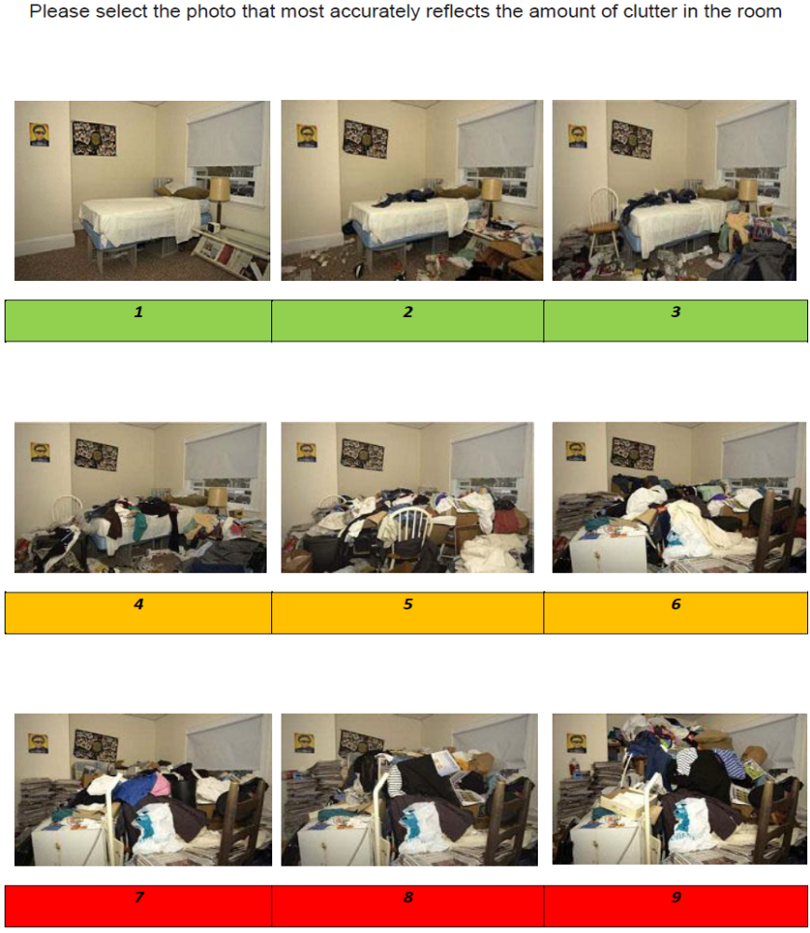

APPENDIX 7

Clutter Image Rating – Living Room

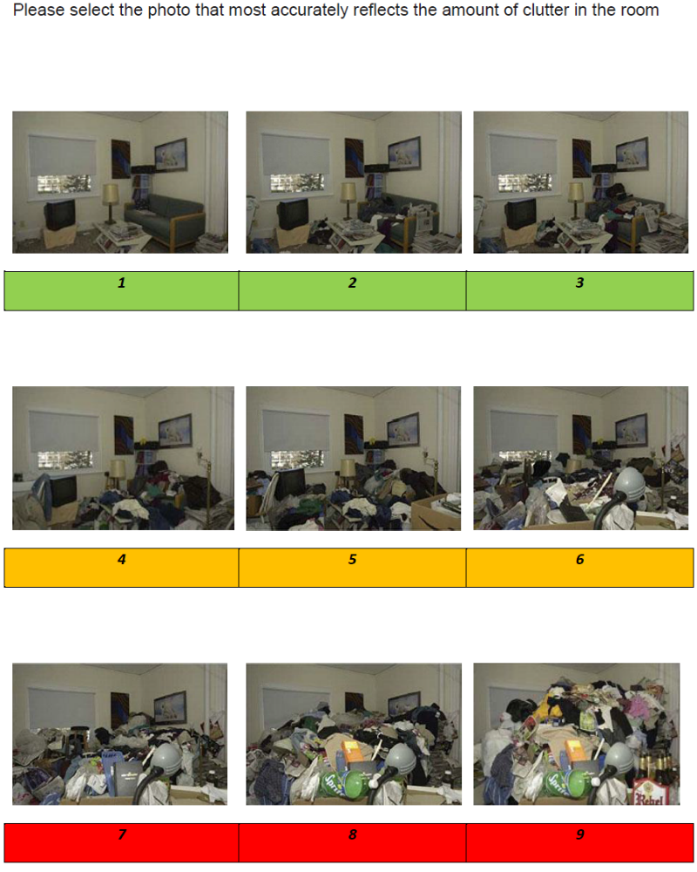

APPENDIX 8

Clutter Image Rating - Kitchen

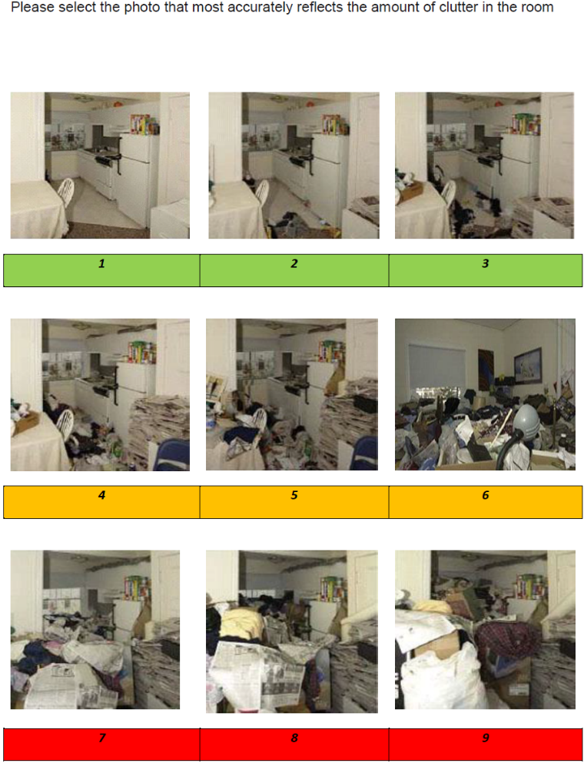

Appendix 9(a)

Mind in Cambridgeshire

S2R Criteria

(Support to Recover programme)

Basic Eligibility Criteria: (To engage and commence in S2R)

- Live in Cambridgeshire
- Be aged 16 or above
- Be willing and able to engage in the Support provided
- Be able to tolerate some challenges that we encourage Individuals to face
- Be willing to explore making changes in their life
- To have not been violent towards another person within the last
6 months
- Is not currently in Hospital Care

Triage:

- Referrals can be made from any professional involved in the care of an Individual via our Referral form; an assessment will not be done until the Funding has been approved.
- Referrals are accepted from persons wishing to self-refer and self-fund

Assessment:

In order to ensure that individuals receive support suitable to their needs and understand how the S2R service works a Home Assessment will be provided to view the following:

- Environmental Risks are assessed
- Significant risk to self or others
- Alcohol/substance use which would interfere with ability to engage consistently
- A snapshot of the situation in real time

Appendix (9b)
 Referral Form
Service User Details
Title: | Name of service user:
DOB: | How did they hear of Mind in Cambridgeshire?
Address: | Landline number:  Mobile number:  Email:
Is it Ok to leave an answer phone message | Preferred method of contact:
Referrer Details
Referral type: Self Professional

Name: Relationship to service user:

Organisation: Contact details:

Is the Client aware of this referral? Yes No

Gp Details
GP name: Surgery:

Address: Contact Number:

Reason For Referral
Please summarise below your reasons for making this referral; giving details of what is happening in your life currently that is having a negative impact on you and what support would be helpful (please tell us what your ultimate outcome/ goal is)

Changing Lives Counseling Changing Lives IAPT Wellbeing Service Support2Recovery

Is there anything about your life/ currently that you feel is unsafe, impacts on yourself or others around you and that you would benefit from additional support with (risk-taking, aggression, discrimination, self-harm etc.)

Preferred Venue and Availability

Support From Other Services
Please indicate whether there is currently any involvement with other agencies that are providing specific support e.g. Addaction, Inclusion, Probation Service etc. Yes No Not sure

Name: Role: Contact details:

Name: Role: Contact details:

Is there currently any involvement with a mental health professional from the NHS (psychiatrist, Care Coordinator, Support Worker etc.)? Yes No Not sure

If you answered yes to this question, please give details and include a copy of the most recent Care Plan with the referral

Name: Role: Contact details:
Date |  | Signature

For Office Use Only
Allocated Worker:
Date |  | Type of contact |  |  | Outcome
 |  | Telephone Letter/ email |  |  | Unable to contact Allocate assessment
 |  | Telephone Letter/ email |  |  | Unable to contact Allocate assessment
 |  | Letter/ email |  |  | Deadline for contact ………………………………
When the deadline to contact has been exceeded contact the referrer to notify them that we have been unable to engage the SU and archive the referral
 |  | Telephoned referrer  Letter/ email sent to referrer |  |  | Referral to be archived
Is this person appropriate for service |  |  | Yes No
Does this person require signposting to more relevant services/ support  If you answered yes to this question, please confirm details |  |  | Yes No  …………………………………………………………………………………  …………………………………………………………………………………
Completed by |  |  |  | Date

Appendix 10

Handy tips for people who display hoarding behavior

The basics
When you are dealing with your hoarding issues here are some basic guidelines that would be helpful for you.

Time
Time is precious. We have demands on our time which often conflict with our needs and those of others. It is important to remember to make time
for yourself, it is about honoring yourself. It is not selfish to think about putting yourself first. We often put others first and do not consider our own personal needs and what is important for us.

Remember, the time you give yourself does not have to be huge. You can begin by allowing yourself half an hour each day to work on your issues. As you progress you will find that you may prefer to allow yourself more time. Making time for yourself will also help you to start managing your day better.

Tips for making time
- Write down all the things that you do each day for a week

- Draw up a schedule for all your routine activities, e.g. work, sleep, shopping, leave the gaps clear.

- Identify a period of time that you can commit to on a regular basis for dealing with your hoarding

- Keep to the schedule, in the same way we always keep to our schedule to go to work. Keeping to the schedule will ensure that you will be consistent with doing your tasks

- Record each day you have done it, this helps reinforce and remind you that you have made the time to deal with your issues. It will also help you have the consistency in undertaking the work you have planned to do.

Obstacles
Obstacles are common, look out for them as they can be traps and prevent us from doing what we need to do:
- I am too tired,
- I don’t have the time,
- there is too much to do

When you face an obstacle ask yourself how is this helping me in dealing with my problem? Break the task into smaller segments to make it more
manageable.

“I don’t have anyone to report to about what I have done”

“It is not important”
Tell a friend you are going to do an important job, you don’t need to discuss the details and you will need to report back that you have completed the task. Being accountable to someone will motivate you to make the time.

Photograph your home
Take photographs of your home before you start. It will be a record of what your environment looked like before you started. The photographs can be an important way to record the progress you make.

Tips
- Take the photographs from the perspective that covers the biggest area
- Take the photographs from the same location each time to ensure consistency and prevent you from distorting your progress
- Take weekly photographs of the area you are working on to monitor changes and as a record of your progress

Obstacles
“I’m concerned about having the photograph developed and someone seeing them”
Most cameras and smartphones take digital images that can be downloaded and stored on a computer or a disk. These images are yours and no one can forcefully ask to see them.

“Someone might see them.”
These photographs are yours and if you have them on your digital camera or smartphone you can control who has access to them.

“I don’t have a computer or the knowledge to use a computer”
If you don’t have a computer or the knowledge to use a computer, then access to the photographs can appear limiting, but the photographs can be stored on your camera or phone. If you have a friend that you trust you could ask your friend to help you move them to a computer. Most libraries have computers that can be accessed for use.

“I don’t want to look at them”
It is understandable that initially you may not wish to look at the photographs, but do still take them - you don’t have to look at them. In time, you may find that you would like to see what your environment looked like and compare the past and the present.

Identifying an area to work on
Before you begin you will need to identify an area that you are going to concentrate on. It is within our nature when clearing to move from one area to the next. As you are going to be dealing with the clutter, you need to identify an area where you are going to start.

Tips
Locate an area that is important to you to begin with, for example your bedroom as it is important for you to have a clear bed to sleep on, or your
kitchen as it is important to have somewhere to cook your meals in. Once you have located a significant area, select a section within that area that you are going to work in. Work consistently in this section before moving on to another area. By maintaining your focus on this area, you will find that as it clears, you will notice the difference and this will in turn motivate you to keep working on your hoarding issues.

Obstacles
“I am finding that as I work on the identified area, I keep doing other things or move to another area instead”

There may be a number of reasons for this; it may appear to be too difficult, you may feel overwhelmed or like you cannot cope, maybe
other areas appear to be easier or more interesting.

To deal with this obstacle, keep your clearing session short and focused.

Plan to do it before doing something pleasurable or fun, e.g. before going out, having dinner, etc. Step back and review what you have achieved so far to help remind yourself of what you have achieved.

“I am not doing enough, my room will never be clear of all the things I have in there”
Recognize that you are working in one area in a systematic way, and you are gradually going to work on the whole area. Think of it as if you are doing a jigsaw puzzle and slowly but surely the puzzle will be complete.

Keep a record of how much you have done
It is always helpful to keep a record of what you have thrown out; the detail of what has been discarded is not important but the quantity can be, e.g. how many bags have you used, or how much space has been cleared?

It is normal to have good and bad days; on bad days it is often easy to feel despondent. When we feel this way, we tend to forget what we have achieved so far. Keeping a record will remind you how much you have done and how far you have come.

Tip
Keep a record on a daily basis, preferably as you go. Don’t leave it until the next day, you will forget how much you have done and doubt yourself.

Obstacles

“I can’t be bothered to write it down”
Take photographs of the bags you are going to throw away.

Keeping a record does not have to be a complex task. Marking the number of bags thrown out on your schedule or calendar for the specific date is an easy way to record what you have been able to do.
Be creative. You can use color dots where each color represents a specific number, for example, a black dot may represent one bag or a red dot may represent five bags that have been taken out of your environment.

Stay with the feeling
Doing things which are not part of your normal routine could cause you to feel uncomfortable and anxious. Learn to stay with the discomfort and move on, and it will pass. The more we react or try to get rid of the uncomfortable feelings, the stronger they will get as you are making them more significant. By letting them be, they will pass and you will be able to recognize your ability to cope with uncomfortable feelings.

Tip
Recognize and accept the way you are feeling. Accept it as it is normal to feel uncomfortable and anxious whilst you are doing things that you would not normally do. Be in the moment and engage in whatever you are doing. Stop thinking about your thoughts and questioning your feelings and be part of what is happening around you. Put on some music or the television in the background or have a friend be with you whilst you are sorting and clearing things out.

Obstacles

“It is too uncomfortable, I can’t cope with it”
Accept the way you are feeling, don’t fight it and it will pass. The more you try to get rid of it, the more significant it becomes. Recall and recognize the other times when you have felt like this and survived it.

“It will never go away”
The more you engage with the feeling, the longer it will last. By having a dialogue with the feeling, you are making it more significant and pronounced and this will lead to it becoming more uncomfortable. Think of the times when it has been hot and there was nothing you could do about it and how over time you tolerate the heat.

Eliciting Support
It can be helpful to elicit support from family and friends. Sometimes just being aware that you have family and friends you can talk to may be adequate. Sometimes, having their physical presence when you are dealing with your clutter can be of great value. Family and friends can provide support in many ways from providing emotional support to actually physically helping with getting rid of things.

Tips
Speak to your family and friends and let them know what you would like from them. Let them know what support you need and how would you like them to provide that for you. Be clear and set some ground rules that would make it easier for you, e.g.
“I just need you to be with me not doing any of the clearing” I need you to help me take these bags to the tip or to the charity shop,

Obstacles

“They will judge me”
This is a common fear that people experience, that others will judge them for the fact that their home is cluttered and untidy. In our experience, when people have explained their situation to their family and friends, they have usually been supportive.

“I feel shame”
Shame is another common emotion experienced. Remind yourself that you have not done anything wrong but are just trying to sort out your home and your life. People understand that sometimes others have problems.

The fact you recognize that you have a problem and you are dealing it is often seen as a commendable act and people will respect you for being honest and dealing with a difficult problem.

“They will get rid of my things without my involvement”
Explain to them what is it that you want them to do, e.g. to be around to provide emotional support, to help with the sorting out, etc. Usually people do respect what you ask of them.

Putting things into practice
As you introduce new ways of dealing with your hoarding issues, it will feel unfamiliar and threatening as some of the exercises will involve you doing things differently from how you are used to doing them.

Tip
Take the risk by trying to deal with things differently. Taking risks is healthy and will help you to make changes that you feel are necessary.
We learn from our experiences.

Obstacles
“I do not feel I can do it; it is not something I have done before”
Don’t allow feelings to rule on what you can or can’t do. Instead, go through the experience of trying it, as it will enable you to make an informed decision about whether you can or cannot do it. Ask yourself about some of the things that you do now, have they come from experiences?

Look at how your experience of trying something new can help you to learn and deal with your issues.

“It feels too threatening”
Ask yourself what is threatening, and how is it threatening? Is it just the idea of trying something new or different? Ask yourself, what is the worst that could happen?

Be creative
Sometimes things do not work out as planned. When that is the case, be creative and substitute with something else that is similar. Be flexible, nothing is written in stone as to how it should be done.

Each exercise is a guide, if you find you cannot do it as discussed then be flexible and improvise to do something similar.

Tip
There are many ways to do each task. There is no right or wrong way. Each of us has preferences and we like doing things in a certain way. Be bold, be creative and try doing it differently, in a way that is not familiar.

Obstacles
“I usually put my things in a black bag before I take it out. I have run out of black bags”
Use carrier bags instead, it makes no difference. Bags are just to contain the items. The colour or type of bag makes little difference.

“I can only work on my clothes”
Don’t be fixated on only one type of item. Expand outwards by looking at what else is similar to clothes. Try instead to work on your towels or sheets instead of your clothes.

Celebrate each inch that you regain
Recognize and celebrate each inch of your home that you regain and each activity you engage in. It is not easy, but start by seeing the colour in your home. The clutter has blocked out the light, the floor, walls and furnishing leaving your home dark and dull.

Tip
With each area that you complete, look at it, stand in it, feel it and celebrate what you have regained. It may be uncomfortable at first as it may feel empty, but recognize what you have got back. Invite family and friends in and show them what you have achieved. Mark the area with something colourful to remind you what you have got back.
Look at the photographs that you took before and compare to how it is now. Print them if you can and notice the differences.

Obstacles

“I have not done enough, it is too slow”
Remind yourself that it has taken sometime for your home to become like this and it will take time to get it to where you want it to be. Taking small steps is the beginning. As you get more confident, you will more able to deal with larger spaces and work through them. An inch is better than nothing. These are some of the components of your journey that you will need to consider. These basics are important as they will help you work in a systematic way to deal with your hoarding issues. Having the basic structure will help you to deal with some of the obstacles that you will experience on the route to reclaiming your space and your life.

For support or information please contact:

HoardingUK Davina House
137-149 Goswell RoadLondon EC1V 7ET
T: 020 3239 1600 M: 07444 791 500E: info@hoardinguk.org www.hoardinguk.org

Used with permission copyright@adapted from overcoming hoarding by Satwant Sing, Margaret Hooper and Colin Jones 2015

APPENDIX 11

For guidance on how to determine the Risk score, please see the Risk Assessment Tool below

The generic Risk Assessment Form and Risk Scoring tool is attached in this appendix. Please use the Guidance Questions and the Premises Risk Assessment Checklist here to help to complete the Risk Assessment form and to work out the scoring.

Risk Assessment Tool (11a)

Step 1:
Determine the Likelihood (L) – what is the likelihood of harm occurring?
Likelihood Score | Description
Rare (1) | This will probably never occur (once every few years)
Unlikely (2) | Do not expect this to occur (once in a year)
Possible (3) | May occur occasionally (one or two times a year)
Likely (4) | Will probably occur, but not a persistent issue (one two times a quarter)
Almost Certain (5) | Will undoubtedly occur frequently (daily/weekly occurrence)

Step 2:
Determine the Consequence (C) – what is the consequence of the harm occurring?
Choose the domain. This will be either the harm to the individual or to the service/organization. Then choose the most appropriate consequence based on the information known at the time.

 |  | Domain
 |  | Harm to person | Harm to Service/Organization
Consequence Score and Definitions | No Harm (1) | - No harm/negligible (e.g. bruise/graze)  - No time off work | - Loss of service <8hrs  - Financial loss <£1,000  - No publicity
Consequence Score and Definitions | Minor (2) | - Minor treatment required (e.g. First Aid)  - Time off work <7 days | - Loss of service >8hrs  - Financial loss £1,000-£5,000  - Media enquiries
Consequence Score and Definitions | Moderate (3) | - Short term harm (e.g. fracture/ serious burn)  - Time off work >7 days  - RIDDOR reportable (specified injury, lost time incident, disease)  - Reportable safeguarding incident | - Loss of service > 1 day  - Financial loss £5,000-£10,000  - Local media coverage  - RIDDOR reportable (dangerous occurrence)  - Reportable incident to external regulator (e.g. CQC, HCA, OFSTED)
Consequence Score and Definitions | Severe (4) | - Long term/permanent harm: permanent lessening of bodily function (e.g. loss of limb) | - Loss of service > 1 week  - Financial loss £10,000-£100,000  - National media coverage <3 days  - Service closed by regulator
Consequence Score and Definitions | Catastrophic (5) | - Death as a direct result of the incident | - Permanent loss of service  - Financial loss >£100,000  - National media coverage >3days  - Prosecution

Step3: Calculate the risk score –Risk score (RS) = Likelihood (L) x Consequence (C)

Using the scores that you got in steps 1 and 2, use the table below to determine the risk score

 |  | Consequence (C)
 |  | No Harm  (1) | Minor  (2) | Moderate  (3) | Severe  (4) | Catastrophic (5)
Likelihood (L) | Rare (1) | 1 | 2 | 3 | 4 | 5
Likelihood (L) | Unlikely (2) | 2 | 4 | 6 | 8 | 10
Likelihood (L) | Possible (3) | 3 | 6 | 9 | 12 | 15
Likelihood (L) | Likely (4) | 4 | 8 | 12 | 16 | 20
Likelihood (L) | Almost Certain (5) | 5 | 10 | 15 | 20 | 25

The Risk Score (RS) indicates the level of risk Example: If a risk was unlikely/severe, the risk score would be:
1-6 = green Unlikely (2) x Severe (4) = 8
7-15 = amber This example would be an amber risk
16-20 = red

Appendix 11b
General Risk Assessment Form

Risk ID | What are the Hazards? | Who is affected? | Likelihood (L) 1-5 | Consequence (C) 1-5 | Overall Risk Score (LxC) 1-25 | Risk Rating  (Red, Amber or Green) | Existing Control Measures in place | Actions needed (by whom) | Review date due

Date of visit and risk assessment
Name of person whose property is visited and their date of birth
Address and contact details
Type of dwelling e.g. freeholder or leaseholder, tenant (include name of landlord)

Names of household members and dates of birth

Pets – number and type

Agencies currently involved - statutory and non-statutory

Name and signature of person carrying out the Risk Assessment and date
Their employer/organisation name and contact details
Signature of person whose premises are the subject of the risk assessment and date

Appendix 11c

Guidance Questions to ask the person when assessing risk at their property:

You may need to adapt questions to suit the person and sensitivity of the situation.

- How do you get in and out of your property?
- How safe do you feel living here?
- Does anyone else live here?
- Do you have regular visitors? children/grandchildren
- How is there health?
- Are they taking any medicines? what for
- Any mobility issues? Any mobility aids they should be using but can’t because of access issues?
- Have you ever had an accident, slipped, tripped up or fallen? How did it happen? How have you made your home safer to prevent this from happening again?
- (Where the floor is uneven or covered, or there are exposed wires, damp, rot, or other hazards): How do move safely around your home?
- Has a fire ever started by accident? How did it start? What happened?
- How do you get hot water, lighting, heating in here? Do these services work properly? Have they ever been tested?
- Do you ever use candles or an open flame to heat and light here or cook with camping gas?
- How do you manage to keep yourself warm? Especially in winter?
- When did you last go out in your garden? How safe do you feel to go out there? If not, why not?
- Are you worried about other people getting in to your garden to try and break-in? How worried are you? Has this ever happened?
- Are you worried about mice, rats or foxes, or other pests? Do you leave food out for them?
- Have you ever seen mice or rats in your home? Whereabouts? Have they eaten any of your food? Have you seen them upstairs?
- Can you prepare food, cook and wash up in your kitchen? How do you manage?
- Do you use your fridge? Can I have look in it? How do you keep things cold in the hot weather?
- How do you keep yourself clean? Can I see your bathroom? Are you able to use your bathroom and use the toilet ok? Do you wash, bath or shower?
- Where do you sleep? Can you show me where you sleep? Can I see your upstairs rooms? (If there are any): Are the stairs safe to walk up?
- What do you do with your dirty washing?
- Are you able to change your bed linen regularly? When did you last change them?
- How do you keep yourself warm at night? Have you got extra coverings to put on your bed if you are cold?
- Are there any broken windows in your home? Any repairs that need to be done?
- Do you find it difficult to use some of your rooms because of the number of possessions you have? If so, which rooms?
- How do you feel about discarding things? How difficult or easy is it to discard thing, or recycle, sell, give away?

Appendix 11d
Risk Assessment checklist
Premises Risk Assessment Checklist |  | Tick and notes
1. Fire Service | - Are there working smoke alarms? How many and where?  - Is the cooking area clean and free from clutter?  - Is the area around the fire/heater free from clutter?  - Are candles being used?  - Evidence of inappropriate use and/or overloading of electrical extension cables?  - Are exit routes, hallways and stairs blocked or difficult to pass due to the clutter?
2. Property structure, services  and  garden area | - Limited access to the property due to extreme clutter  - Garden not accessible and extensively overgrown  - Services not connected or not functioning properly  - Concern with the integrity of the electrics  - Property lacks ventilation due to clutter  - Unsafe storage with risk of toppling or breakage causing personal injury  - Evidence of structural damage or outstanding repairs, or damp, with risk of excessive loads on the upstairs floors or loft space  - Interior doors missing or blocked open  - Evidence of indoor items stored outside  - Evidence of outdoor items being stored inside  - Property is not maintained within terms of lease or tenancy agreement where applicable
3. Household Functions | - Clutter is preventing the use of rooms for their intended purpose  - Inconsistent levels of housekeeping throughout the property  - Room(s) scores 4 - 9 on the clutter image scale  - Rooms not used for intended purposes or very limited  - Beds inaccessible or unusable due to clutter or infestation  - Toilets, sinks not functioning or not in use  - Household appliances are not functioning or inaccessible  - Broken household items not discarded e.g. broken glass or plates  - Evidence of outdoor clutter being stored indoors  - Concern for declining mental health  Person at risk due to living environment
4. Health and Safety | - Kitchen and bathroom are not kept clean, human urine and or excrement may be present  - Evidence of insect infestation (bed bugs, lice, fleas, cockroaches, ants, etc.)  - Evidence may be seen of unclean, unused and or buried plates, dishes, pots and pans etc.  - Inappropriate quantities or storage of medication.  - Concern for declining mental health
5.Safeguarding of Children & Family members | - Family members also living at property  Hoarding scale 4-9 requires a Safeguarding referral to the adult and children teams as appropriate
6. Animals | - Pets at the property are not well cared for  - Animals at the property at risk due the level of clutter in the property  - Person is not unable to control the animals  - Animal living area is not maintained and smells  - Animals appear to be under nourished or over fed
7. Environmental Health  Environmental Health has a duty to serve a legal notice(s) under some circumstances.  If the answer to Q1 is ‘yes’ and there are one or more answers ‘yes’ to Q2, then refer to Environmental Health | Q1. Would formal intervention by Environmental Health be helpful at this stage?  Q2. Are there:  - Materials at the property likely to attract rats or mice i.e. food left over night or items they could nest in?  - Spider webs in property  - Does the property have a strong odour that materially affects neighbouring properties?  - Is the property filthy? (human or animal excrement)  - Is the property rented and in disrepair? Could works be done in the ‘clutter’?  - Is the property in disrepair and affecting neighboring properties i.e. damp, drainage, structural damage?

TOP TIPS -High risks from fire

- Make it a priority to keep the cooking area clear of clutter both on, in or around a traditional or portable stove

- Exit and entry routes should be clear of clutter at all times

- Fused extension cables (trailing sockets) and not extension blocks should be used. Leads from under the clutter should be removed as they are likey to overheat and start a fire.

- Items on or close to heaters, lamps, naked flames or other electrical equipment should be removed

- Candles/tea lights should be in heat resistant holders, ensuring they are placed on a flat, stable heat resistant surface. They should be kept away from anything that can catch fire, and never left unattended. LED candles could be used instead.

- Advocate never smoke in bed or in close proximity to the clutter, ideally go outside. Ashtrays should be robust, fit for purpose and placed on flat, stable surfaces so they can’t tip over easily

- If there are burn marks around a chair where the person sits or falls asleep – recommend a heavy duty ashtray

- Cylinders of any description should not be in anyone’s home as they are a serious hazard during a fire. If there is a medical need for cylinders, they should be kept upright and outdoors where possible - never stored in basements, under stairs or in cupboards with electric meters/equipment

- Ideally possessions should be stored on stable surfaces and not stacked to a height that they become unstable – they could fall over blocking the residents escape route

- Newspapers, mail and video tapes stored in bulk are highly combustible and will cause a fire to spread rapidly. Encourage the resident to sort mail and newspapers as it arrives, and recycle/dispose of them daily to avoid a build up

- Ensure there is at least one working smoke alarm on each level and that they are tested weekly

- Ask the resident to plan and practice their escape plan. Keep routes in and out of rooms clear to assist themselves and firefighters should they need to help the resident out of their property

- In the event of a fire, they should not attempt to put it out. They should leave straight away and call the fire and rescue service once they are safely outside. They should not stop to collect possessions or go back inside once they have escaped

